ERIKA: Bolivia is located in South America. Children live in difficult conditions,but they manage. The difficulties are that children find it difficult to come to school and in dangerous conditions. Their school is not like ours,but I like it. Given the conditions in which they live,they are happy with every thing they have.
ANTONIO B. The state of Bolivia is located in South America. Children live a very modest life by not having toys and clothes to go to school by extreme means. They have a lot of difficulties in learning and the way to school. Our school has a lot more technology and they don”t have that, so they can”t have tasks with the internet and electricity.
ANTONIO D.K. The city of Bolivia is located in the country of South America. Children live very hard to feed their beggars, eat with their fingers, brush their teeth in a barrel of water, their kindebret is built of rock, they go to school on foot in various ways and for very long hours, and sometimes when they go to school they get hungry and eat a special plant. The difficulty with school is that they need to walk a few miles unless someone stumbles and throws them to school, and we now have transportation so we don’t walk at all all the time. They also have a couple of benches at school and their table walls are damaged, and they get biscuits and bananas for lunch, and we are fed as if we were in a restaurant, and we have better conditions at school.
IVA: Bolivia is located in South America.
Young children live on the streets.
They sleep on bridges.
Begging for food.😞
Rarely does a family live in a house.
In Bolivia children are not sent to school.
School there is not compulsory.
LEON: The country I have chosen is Kenya which is located in Africa. Unfortunately there are a lot of children there. No slippers or a normal house, not to mention long trips to school, a lot of time to school.

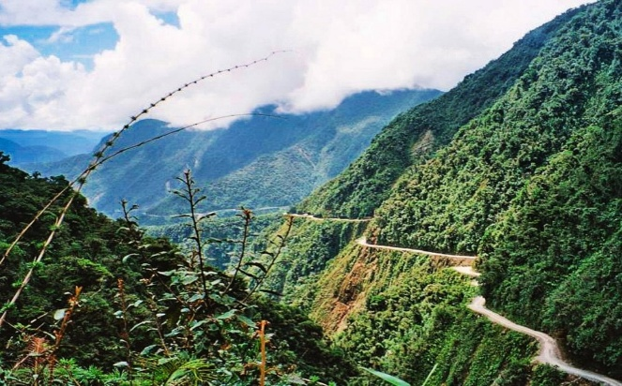
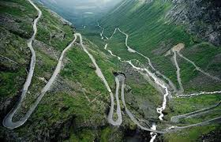
DORA: They climb mountain trails, swim across rivers or break through icy desolation with -50 degrees Celsius. Their path takes them through amazing natural landscapes, creating spectacular landscapes for a very ordinary task. Attendees, sometimes without shoes and for days on end, are ordinary students on their way to school. This series impresses with a unique blend of breathtaking landscapes, huge battles and dangers combined with children’s curiosity and happiness. Each of us remembers our journey to school. But how exciting would it be if it passed through the African steppe, with crocodiles appearing occasionally? Or when the school road was a narrow path along a steep gorge that fell into a deep void?

SILVIA: The documentary series is about children from Bolivia living in difficult conditions and going to school every day in dangerous places through the rainforest, hungry and exhausted. They walk a lot of miles and risk their lives so they can get to school and have a better future. As I watched this series about children I was very scared as I watched all the kids make their way to school and I realized how much easier it is for us kids to travel to school. I was especially pleased with how harmonious the children are and help each other in everything. They are all the same as one, not like with us. If someone has a program at school everyone immediately talks about it and makes fun of it as if it is less valuable than others.
https://www.canva.com/design/DAD-qXME8ZI/v45bfw8gJbgqBJ5JzEwibg/view?utm_content=DAD-qXME8ZI&utm_campaign=designshare&utm_medium=link&utm_source=publishsharelink#1

MAJA : Colombia
A country in South America. In Colombia, parents wake up at 4 or 3 in the morning to light a fire and prepare breakfast for their children. Children need to get up 2 hours early to get ready to head to school to get to class. Children on their way to school have to cross a steep wooden bridge that is unstable, and some have to cross water. Moms take the children to other students and then together they go through great danger. When children go to school they have a lot of dangerous animals on their way. Children in South America have a very difficult life, an even harder way to school. In our country and in some other countries, it is completely different, our parents take us away, we go on foot or a bus comes to pick us up.

