DUBLIN
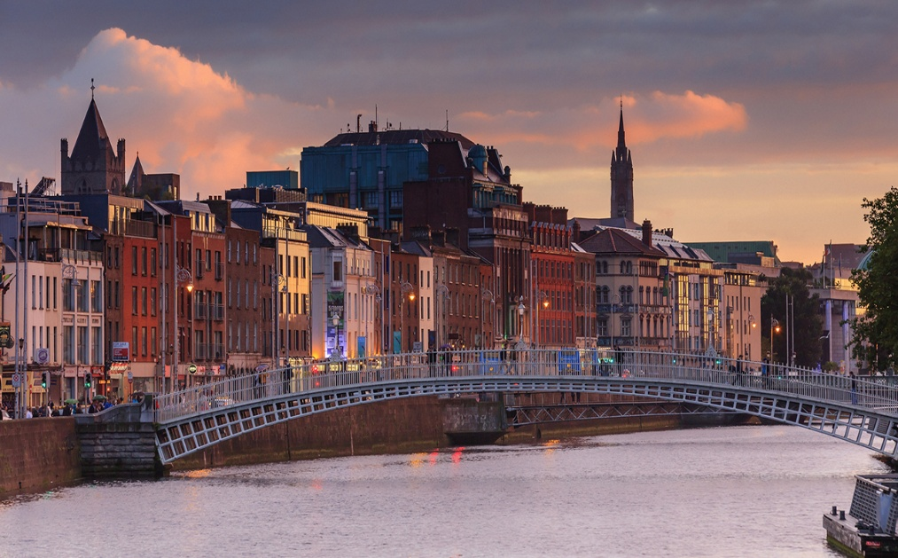
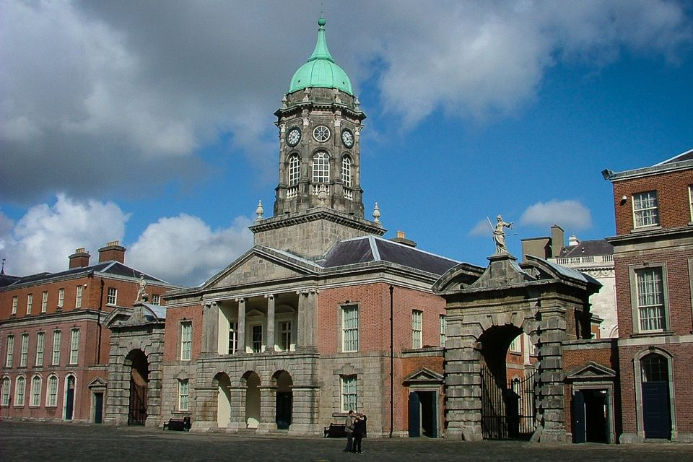
Dublin is capital and biggest city of Ireland. Dublin have 2 milions people. 1592. in Dublin was estabilished Trinity College, the oldest Ireland univeristy. Year 1864. was estabilished Irish national museum. Dublin is on river Liffey.

