Ireland
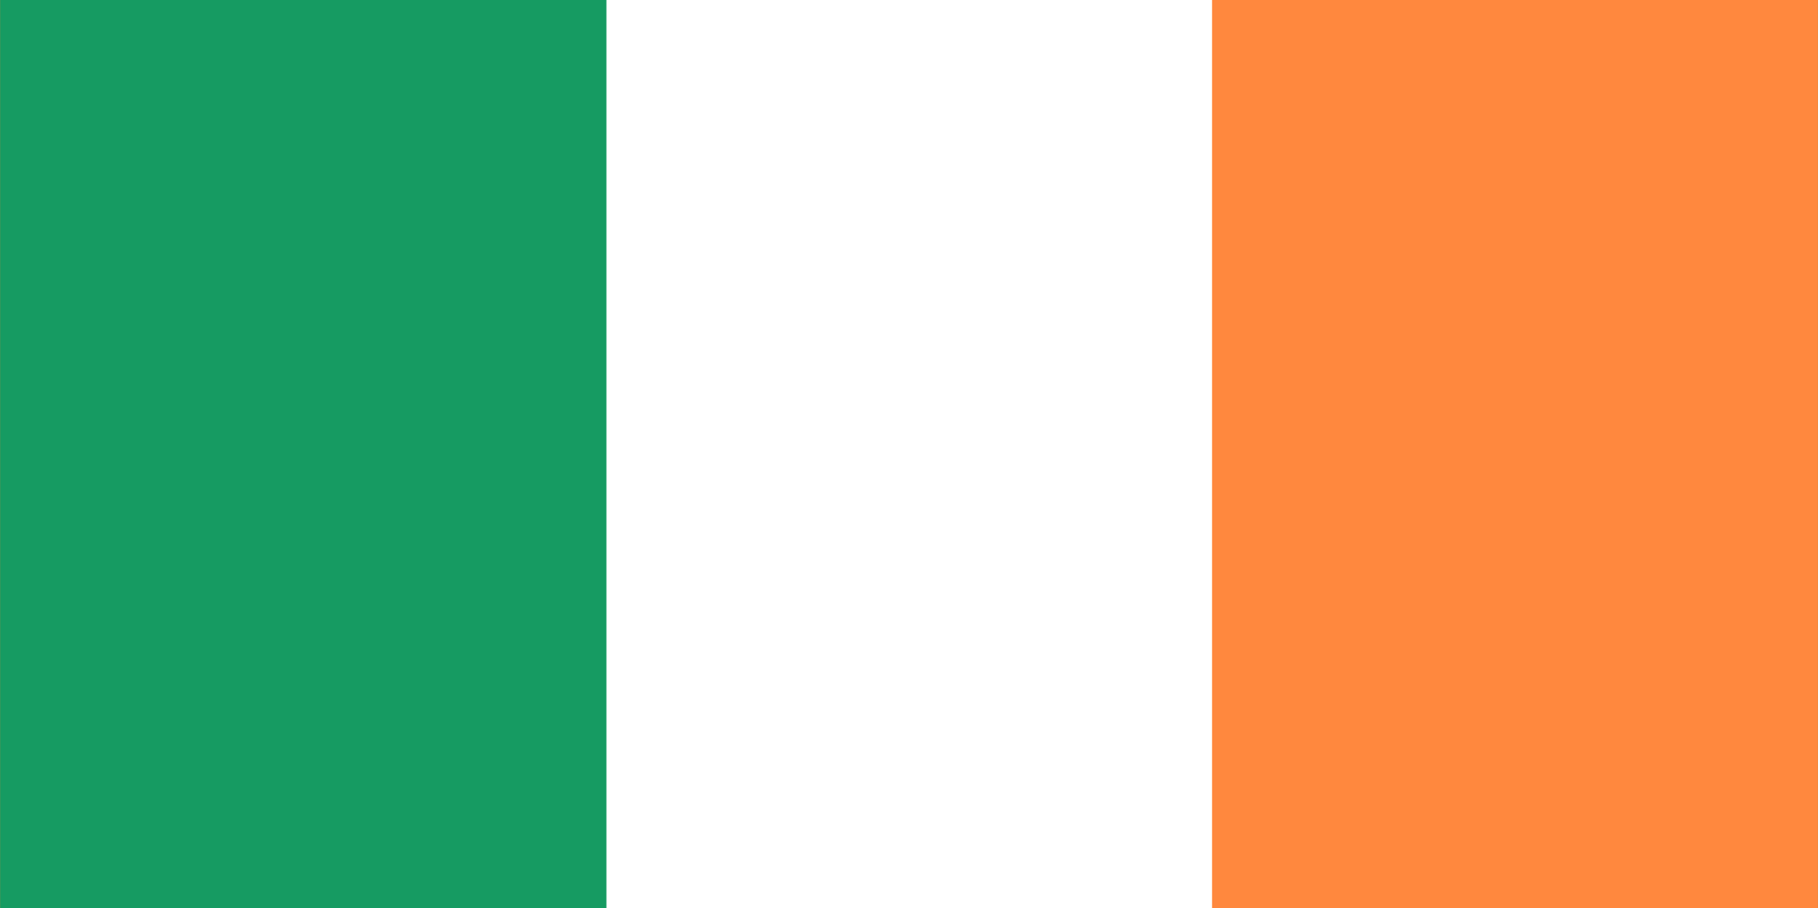
The Republic of Ireland is situated in the north-west of Europe. The capital of the Republic of Ireland and its biggest city is Dublin. The patron saint of Ireland is St Patrick. The symbol of Ireland is a shamrock.
-flag of Ireland

BLARNEY CASTLE
Blarney Castle is a medieval stronghold in Blarney. The castle is a partial ruin with some accessible rooms and battlements. Surrounding the castle are extensive gardens. At the top of the castle lies the Stone of Eloquence, better known as the Blarney Stone. Tourists visiting Blarney Castle may hang upside-down over a sheer drop to kiss the stone, which is said to give the gift of eloquence.
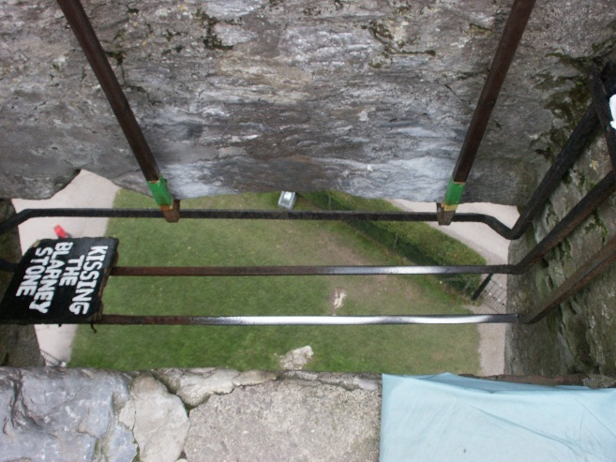
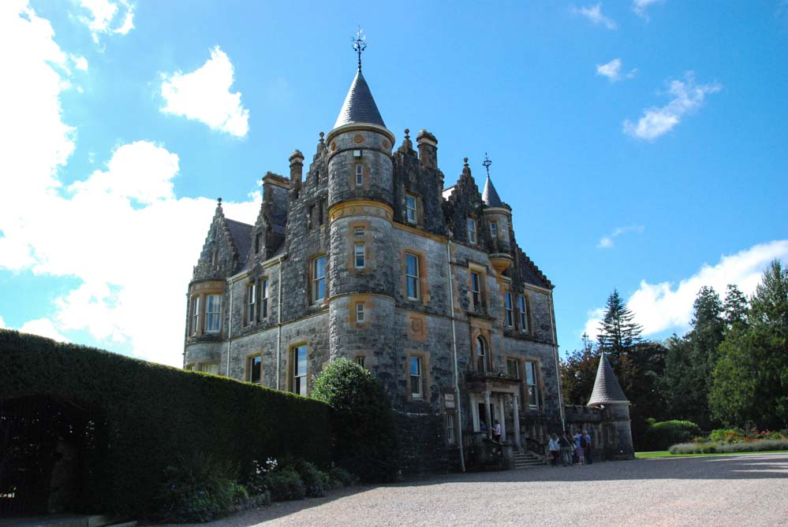
-the Blarney Stone

